|  |  |  |  |
| --- | --- | --- | --- |
| **Lyng Primary School Knowledge Organiser** | | | |
| **Topic:** | **Ancient Romans – What is life like in the Alps?** | Year 5  *Civilisation, Communication and Creation* | Summer 1 and 2 |

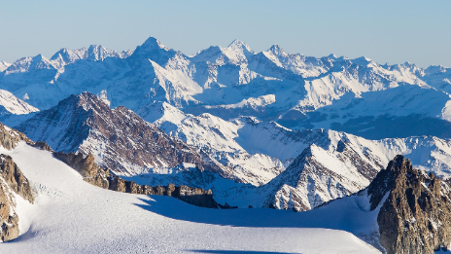Related image

**Background information for parents and teachers.**

**The Alps**

**The Alps is a mountain range in Europe which formed millions of years ago. It is the result of the Eurasian and African tectonic plates colliding. It has been eroded by glaciers, rivers and precipitation over that time.**

|  |  |
| --- | --- |
| **What Step On and Goldilocks words will I use?** | |
| **Spelling** | **Definition** |
| Fold mountain | A mountain created when to tectonic plates are pushed together, pushing the ground upwards. |
| Latitude | How far north or south a place is located. |
| Mountain range | A series of mountains located close together. |
| Longitude | How far east or west a place is located. |
| Hemisphere | A half of the Earth divided by the Equator into the Northern and Southern Hemispheres. |
| Climate | Long term weather conditions in a specific region. |
| Sea level | The base level for measuring land height on Earth. |
| Land height | The position of a point above sea level. |
| Mountain climate | A mountainous region with a colder climate than the surrounding area, affected by the height of the mountains. |
| Temperate | A region with mild temperatures. |
| Temperate forest | A biome containing deciduous trees at lower levels and coniferous trees at higher elevations. |
| Deciduous trees | Trees that shed their leaves in autumn and winter. |
| Coniferous trees | Trees that do not shed their leaves in autumn and winter. |
| Tourism | Travel for pleasure when people visit places of interest. |
| Recreational land use | Land use that provides leisure activities |
| Glacier | A slow-moving mass of ice formed by the accumulation of compact snow on mountains. |

|  |
| --- |
| **Geographical study** |
| * Locate the Alps on a world map and identify and label the eight countries they spread through. * Locate three physical and three human characteristics in the Alps. * Research and describe the physical and human features of Innsbruck. * Use a variety of data collection methods including completing a questionnaire, mapping their route and recording their findings in sketches or photographs. * Compare the human and physical geography of their local area and Innsbruck. * Describe at least four of the key aspects of the human and physical geography of the Alps to answer the enquiry question, ‘What is life like in the Alps?’ |

**Fieldwork Opportunities**

•Going out and investigated what leisure facilities are available in our local area.

**Significant places**

The Alps

Innsbruck

**Our Storytelling Approach to enhance engagement**

|  |  |  |
| --- | --- | --- |
| **People:**  Julius Caesar | **Place:**  Rome | **Problem:**  How can I expand my empire? |

**Key facts and locations**

**Map to be studied**

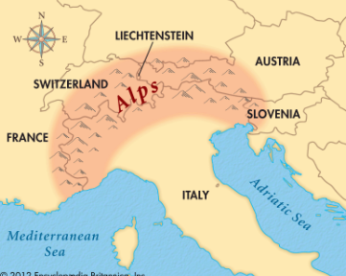

Mont Blanc is the highest peak in the Alps. It’s impressive summit stands 4,806 metres above sea level. It is on the border between France and Italy.

It is estimated that 30,000 animal species live in the Alps making it the most biodiverse region outside of the Mediterranean.

It is one of Europe’s most popular places to visit. For snow sports, tourists visit between December and April to enjoy skiing and snowboarding. People who prefer to hike and explore would visit between May and October.

The town of Innsbruck has been the host of 5 Winter Olympic games and is a popular destination for skiing.

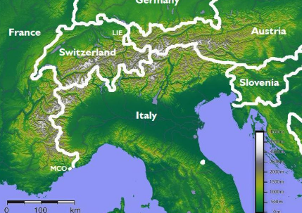

**Agreed Outcome**

A persuasive poster to visit the Alps.

**Key Questions – Sequence of Learning**

* Where are the Alps?
* What is it like in the Alps?
* Why do people visit the Alps?
* What is there to do in our local area?
* How are the Alps different from our local area?
* What is life like in the Alps?

|  |  |  |
| --- | --- | --- |
| **People:**  Julius Caesar | **Place:**  Rome | **Problem:**  **How can I expand my empire?** |

|  |  |  |
| --- | --- | --- |
| 6. Why do tourists visit the Alps? | **S** | **E** |
| To sunbathe on the beach. |  |  |
| To go skiing, hiking, mountain biking and sightseeing |  |  |
| To visit the desert. |  |  |
| To go snorkelling |  |  |
| 7. Climate change is causing… | **S** | **E** |
| more snow |  |  |
| more plants to grow |  |  |
| glaciers to melt |  |  |
| lakes to freeze |  |  |
| 8. What is the name of the popular tourist resort in the Alps? | **S** | **E** |
| Innsbruck |  |  |
| Pompeii |  |  |
| Rome |  |  |
| Athens |  |  |

|  |  |  |
| --- | --- | --- |
| 4. What type of climate do the Alps experience? | **S** | **E** |
| Mediterranean and mountain |  |  |
| Tropical |  |  |
| Polar |  |  |
| Mediterranean and desert |  |  |
| 5. The large bodies of ice that form in the mountains are called… | **S** | **E** |
| glaciers |  |  |
| icebergs |  |  |
| snow |  |  |
| avalanches |  |  |
|  |  |  |

**Our Alps Quick Quiz**

|  |  |  |
| --- | --- | --- |
| 1. In which continents are the Alps located? | **S** | **E** |
| Africa |  |  |
| Europe |  |  |
| Asia |  |  |
| North America |  |  |
| 2. What type of mountains are in the Alps? | **S** | **E** |
| Fold mountains |  |  |
| Volcanic mountains |  |  |
| Underwater mountains |  |  |
| Fault block mountains |  |  |
| 3. How many countries do the Alps spread through? | **S** | **E** |
| Ten |  |  |
| Eight |  |  |
| Four |  |  |
| Two |  |  |